**DOWNLOAD JAVA**

If your PC doesn’t have Java, download it from java official site. [Go to Java Official Site](https://www.java.com/en/download/)

**INSTALLATION:**

After downloading Java, it’s time to install it on your PC. It is not a difficult task and as easy as installing other windows software.

**Steps 1**: Double click on java executable file which you have downloaded.

Java Executable File

**Steps 2**: The installation process is started. Windows security will ask you whether allow or not to run this software. Click yes if asked.

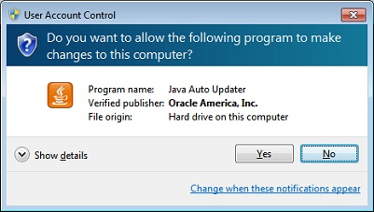

**Steps 3**: Click on Install button to accept license terms and start Installation.

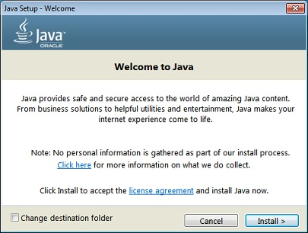

**Steps 4**: Now just do Next > Next > Finish.

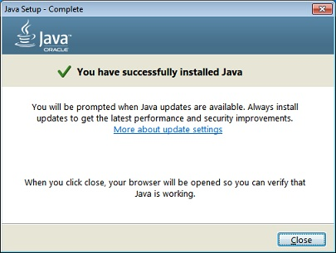

**Steps 5**: Congratulations!!! You have installed Java Successfully on your PC.

Now, it’s time to check whether Java is installed on your PC or not.

Go to **C Drive > Program Files**. Here in the list you will find Java folder.

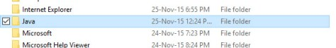

If you get this folder it means Java has been installed on your PC. But it doesn’t mean you are ready for writing and executing java program. One more step is ahead. It is setting Path in System Environment Variable. Until you set path you are not able to compile java code.

**SET JAVA PATH IN SYSTEM ENVIRONMENT VARIABLE**

In order to setting java path you need to open system variable windows first. To open system variable windows you follow these steps.

**WINDOWS 10/8/7, VISTA AND XP**

**Steps 1**: Right click on MyComputer, Computer or This PC and select **properties**.

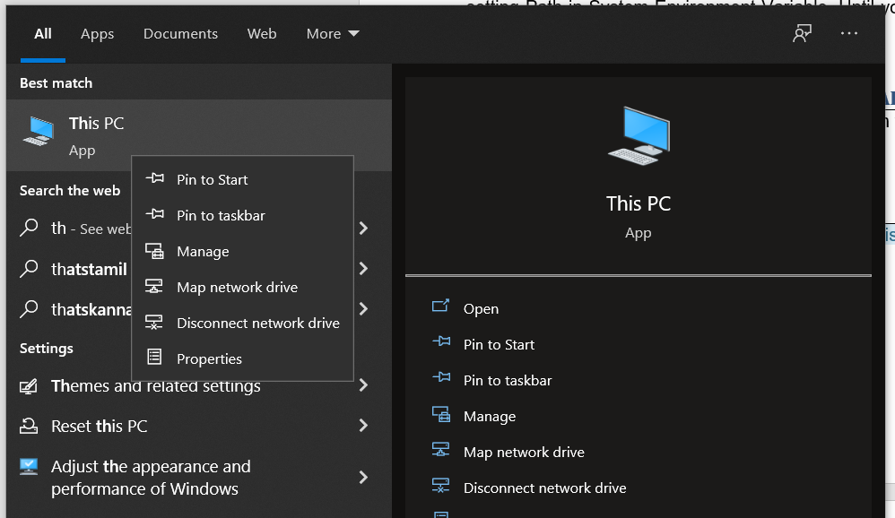

**Steps 2**: In the left side, there is link **Advanced System Settings**. Click on it.

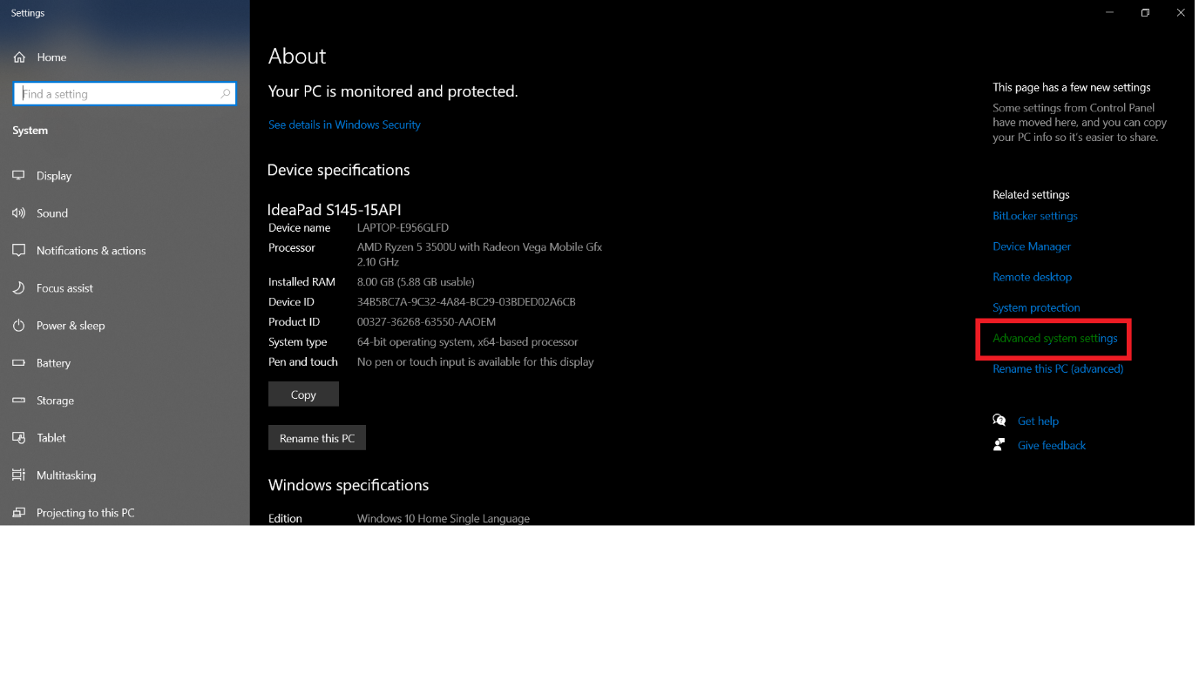

**Steps 3**: Go to **Advanced** tab and click on **Environment Variables**.

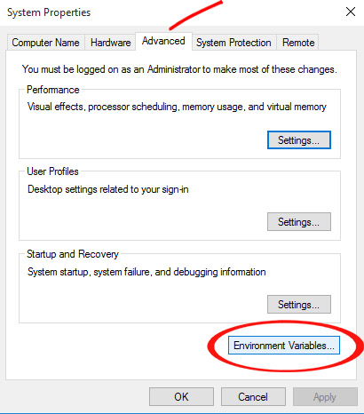

**Steps 4**: In the System Variable Column click on **New**.

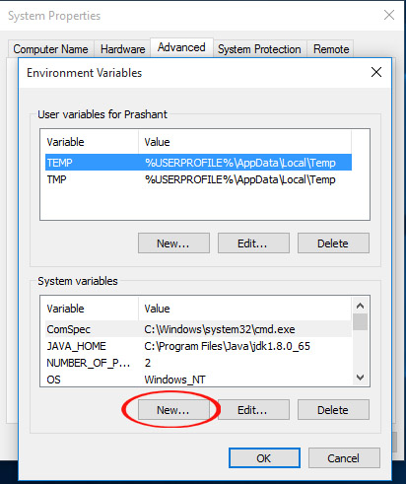

**Steps 5**: In the Variable Name write **JAVA_HOME** and in the Variable Value field Write Java Installation path. It is in your program file location as **C:\Program Files\Java\jdk1.8.0_65**

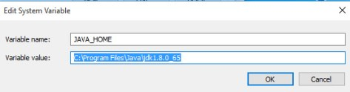

**Steps 6**: Click on OK to save.

**Steps 7**: Now find Path in the variable name and select it.

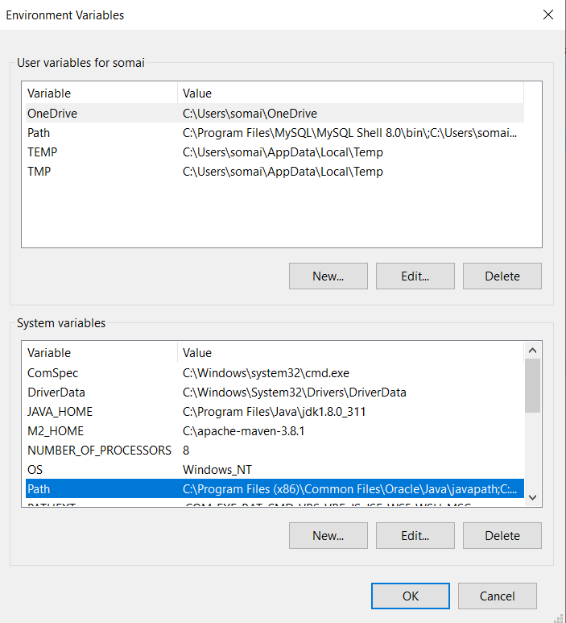

**Steps 8**: Click on **Edit**

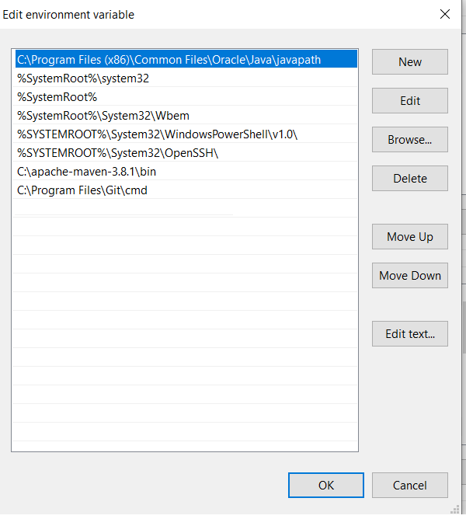

**Steps 9**: Click New Add C:\Program Files\Java\jdk1.8.0_311

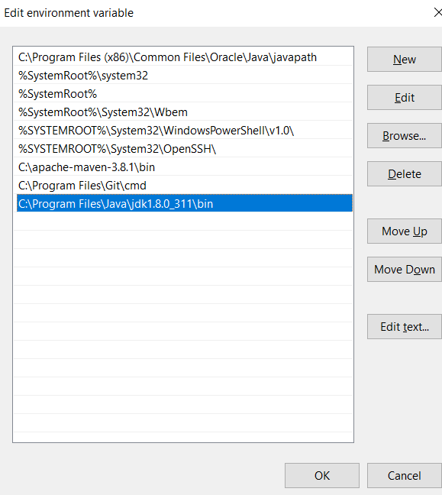

**Steps 10**: Click OK to save.

**TESTING JAVA**

Now it’s time to test whether Java is working on your machine or not. In order to test java, do the following steps.

1. Open **command prompt**. To open command prompt press **windows + R** key and write cmd and press enter. Write java -version in the command prompt. If you get list of java option then cheers! Java is ready on your machine and now you can start java journey.

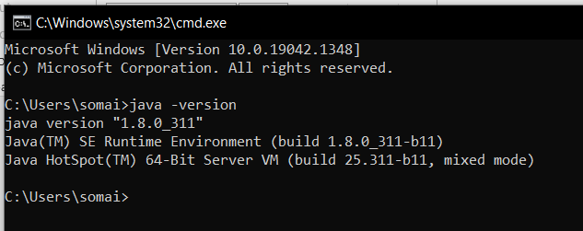

TO INSTALL ECLIPSE

<https://www.eclipse.org/downloads/download.php?file=/oomph/epp/2021-09/R/eclipse-inst-jre-win64.exe>

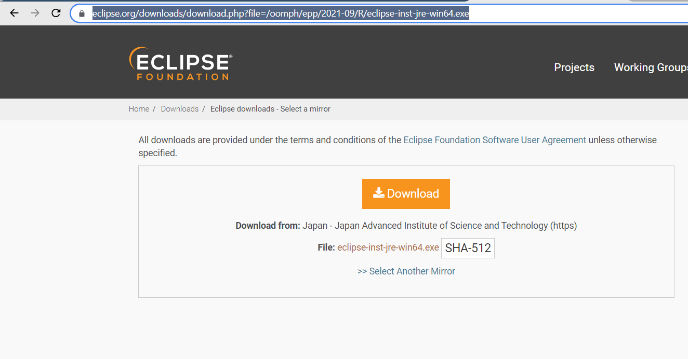

OPEN ECLIPSE.EXE FILE AND CHOOSE ECLIPSE IDE FOR JAVA DEVELOPERS AND CLICK NEXT

